GENERAL PURPOSE REGISTERS (GPRs)

The CPU's Workbench

Think of the CPU as a worker. **Registers** are the worker’s hands or small workbench.

They hold the tools and materials (data, addresses, pointers) the CPU needs right now.



I. Why they matter:

Registers give the CPU instant access to information.

Without them, the CPU would waste time going back and forth to RAM (the big library) or the Hard Drive (the warehouse).

II. How they work:

The CPU can’t use RAM directly. It must first copy data into a register.

Once in a register, the CPU can add numbers, compare values, or move data quickly.

III. Key Points:

* **Location:** Inside the CPU chip.
* **Speed:** Extremely fast — one cycle vs. hundreds for RAM.
* **Volatility:**

The 32-bit Registers

In this modern x86 architecture, we have eight special types of registers called general-purpose registers (GPRs). Each of these GPRs is a single 32-bit block. This is different from the earlier 16-bit registers that were used in older CPU models.



I. Breaking Down Each Register

Let's explore each register and its typical uses:

1. **AX**: Used for addressing data, pointing to specific locations.
2. **BX**: Similar to AX, used for addressing data, but often used for larger values (like 16-bit numbers).
3. **CX**: Often used for addressing data in addition to what's already stored in AX and BX.
4. **DX**: A bit different from the others, it's usually set by the program or hardware to point to a specific address.
5. **BP**: Used for storing addresses of previously loaded data (or code).
6. **SP**: This register holds the stack pointer, which is used to manage memory and return values.
7. **SI** (or **DI**): Usually linked to BP, SI stores the base address of a block of memory.
8. **EAX**, **EBX**, **ECX**, **EDX**: These registers are like AX, BX, CX, and DX, but with 16-bit widths instead of 32 bits.

So, in short, these eight registers provide direct access to your CPU's data storage locations, making them incredibly useful for efficient program execution.

In the x86 architecture, registers have grown over time. Intel maintained backward compatibility, meaning the names tell you the size.

* **8-bit (1970s):** AL, AH, BL, etc.
* **16-bit (1980s):** AX, BX, CX. (The "X" usually stands for pair or extended from 8-bit).
* **32-bit (1990s):** EAX, EBX, ECX. (The **"E"** stands for **Extended**).
* **64-bit (2000s):** RAX, RBX, RCX. (The **"R"** stands for **Register** or Re-extended).

*Note: In this chapter, we focus on the 32-bit "E" registers, as they are the standard baseline for malware analysis and reverse engineering.*

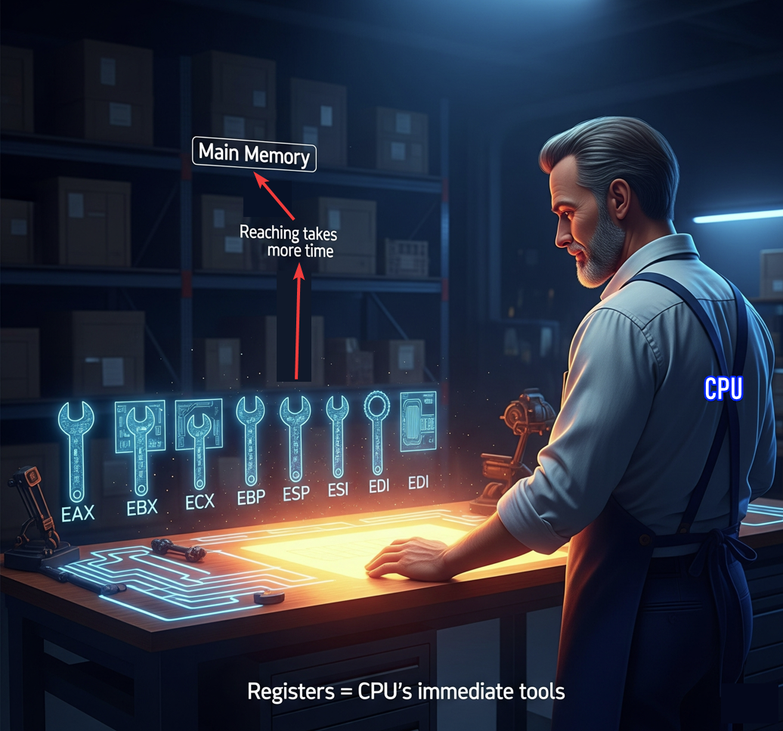

II. The Multi-Role Power Tools

The general-purpose registers in x86 are not just simple scratchpads. They're actually **multi-role power tools** that handle various tasks, such as data, pointers, counters, parameters, addresses, and even system calls.

Think of them like a set of versatile hammers, each one capable of performing different functions. For example:

* **AX** is for moving data - it can be used to load, store, or manipulate data in various locations.
* **BX** is similar to AX, but often used for *larger values* or *addressing higher memory* locations.
* **CX** is another type of register that's often used in addition to AX and BX.

III. Gaining Muscle in Protected Mode

In **protected mode (32-bit),** the general-purpose registers grew stronger and more powerful.

The first eight registers **AX to DI** became **EAX to EDI**, which are like a new set of tools with 16-bit widths instead of the original 8-bit width.

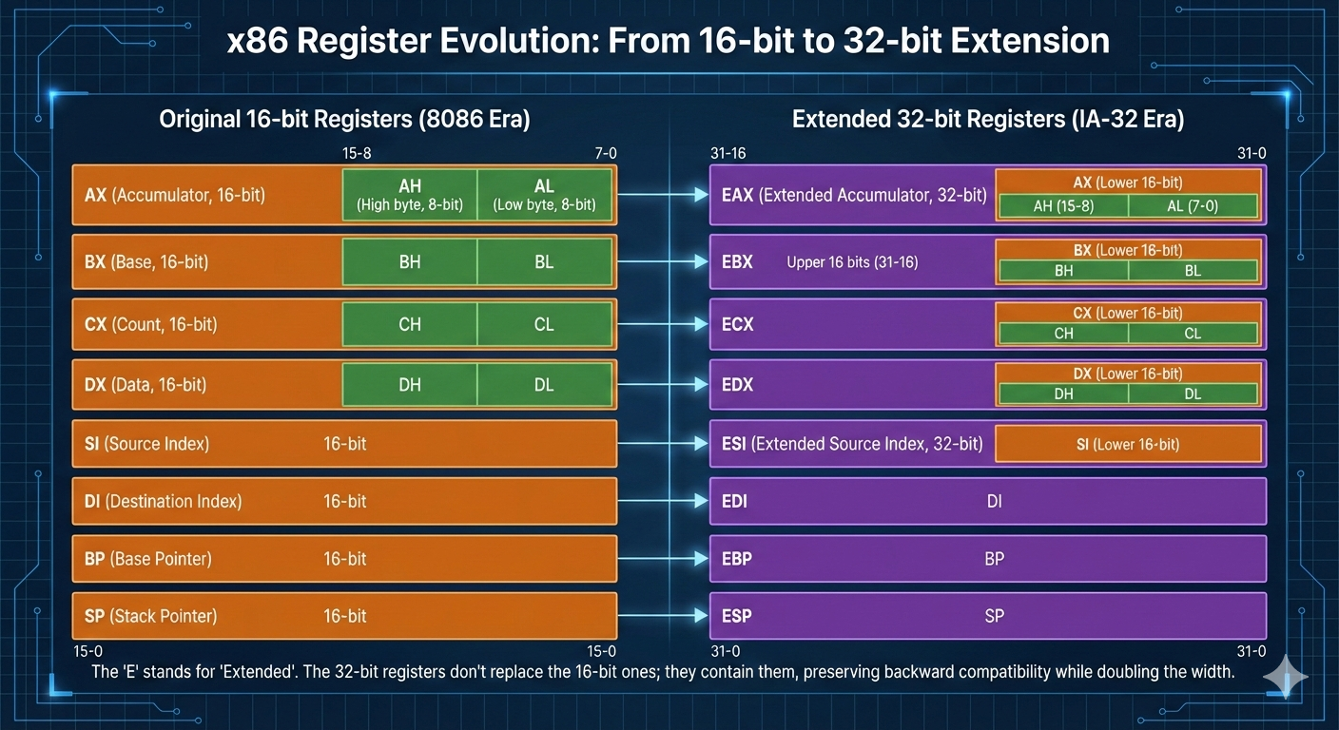

Later, in long mode (64-bit), even more registers were added:

* RAX to RDI: This is another "set of 8" with increased functionality.
* R8 to R15: These additional registers bring the total count to 16, providing a wider range of operations and tools for your CPU.

It's worth noting that these multi-role power tools are not just used in x86 processors; they're also found in other architectures, such as ARM and PowerPC.

3.2 The Core Four: Arithmetic & Logic

These four registers—EAX, EBX, ECX, and EDX—are special because they can be split into smaller pieces.

This comes from very early x86 designs in the 1970s, but it’s still useful today.

It lets the CPU work with single bytes, like characters in a string, instead of always handling full numbers.

I. EAX

EAX is mainly used for math and logic.

Most calculations end up here, and the CPU is optimized to use it fast.

When a function finishes running, its return value is placed in EAX.

Because of this, programs often check EAX right after a function call to see if something succeeded or failed.

For example, after a password check, the code might look at EAX to see if the result was 1 or 0.

EAX can be split into smaller parts: AX is the lower 16 bits, and that can be split again into AH (high 8 bits) and AL (low 8 bits).

II. EBX

EBX is commonly used to hold a base address in memory.

Think of it as pointing to where some data starts, like the beginning of an array or structure.

Older code used EBX heavily for memory access, but modern compilers don’t give it a strict role anymore.

Because of that, it’s often used as a general-purpose register to store values that need to stay around for a while. Like EAX, it can be split into BX, BH, and BL.

III. ECX

ECX is mostly used as a counter.

The CPU relies on it for loops, especially when repeating an instruction multiple times.

There’s even a special LOOP instruction that automatically decreases ECX by one each time it runs.

When copying or moving data in chunks, ECX usually holds how many bytes or items need to be processed. ECX can also be split into CX, CH, and CL.

IV. EDX

EDX is often used as a helper register for EAX. When multiplying or dividing large numbers, the result may not fit in EAX alone, so the CPU uses EDX together with EAX to hold the full result.

EDX is also commonly used in input and output operations, such as storing port addresses. Like the others, it can be split into DX, DH, and DL.

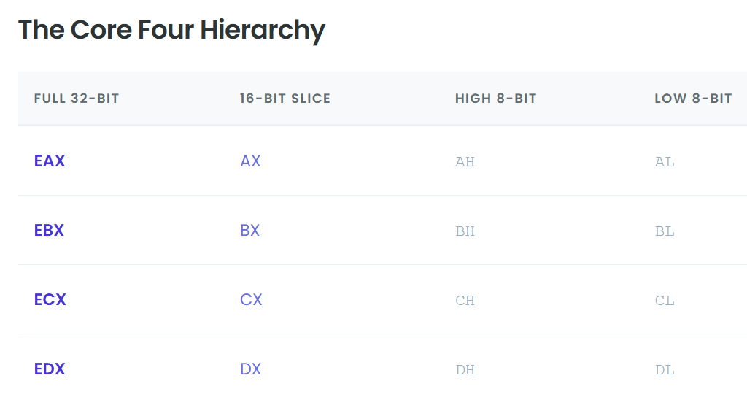

3.3 The Index Registers

ESI and EDI are used when the CPU is moving data in memory.

This usually means copying arrays, strings, or blocks of bytes from one place to another.

You’ll see them a lot in code that handles buffers and string operations because they’re built to do this kind of work fast.

I. ESI - Extended Source Index

Holds the address of the data being read.

It points to where the data starts, like the source of a copy.

When the CPU is moving bytes, it reads them from the memory location stored in ESI.

II. EDI – Extended Destination Index

Holds the address of where the data is being written. It points to the destination, where the copied data will end up. As the CPU copies each byte, it writes it to the address in EDI.

You can think of it like moving stuff from one place to another. ESI is the old place where the boxes are, EDI is the new place, and the CPU walks back and forth moving things from ESI to EDI.

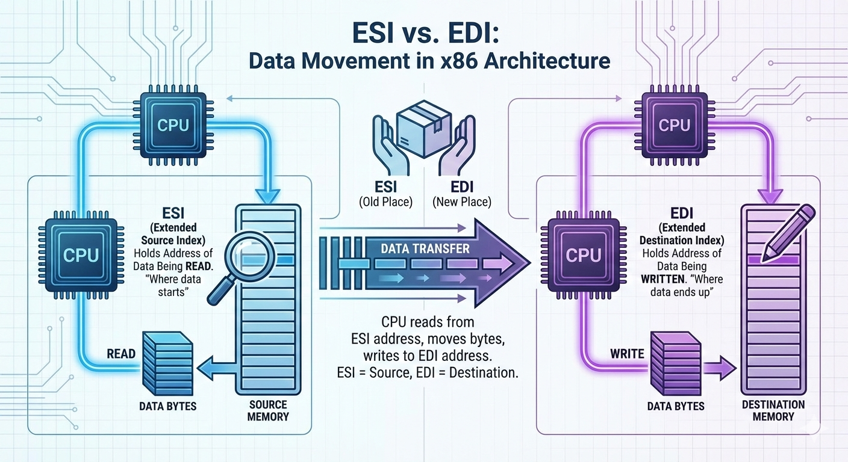

3.4 The Pointer Registers (The Stack)

ESP and EBP are used to manage the stack. These registers are extremely important, and you normally don’t use them for math or random storage.

If they get messed up, the program will usually crash because the CPU no longer knows where the stack is.

I. ESP – Extended Stack Pointer

Always points to the top of the stack.

When a value is pushed onto the stack, ESP moves downward to make space.

When a value is popped off, ESP moves back up.

The CPU constantly updates ESP as the program runs, so it is always changing.

Because of this, you generally should not manually change ESP unless you are writing very low-level code like a compiler or an operating system.

II. EBP – Extended Base Pointer

Used as a stable reference point for a function.

When a function starts, EBP is set to mark the base of that function’s stack frame and then stays mostly the same while the function runs.

This is important because ESP keeps moving as values are pushed and popped.

By using EBP, the program can reliably access local variables and function parameters using fixed offsets, like **“EBP minus 4”** or **“EBP plus 8.”**

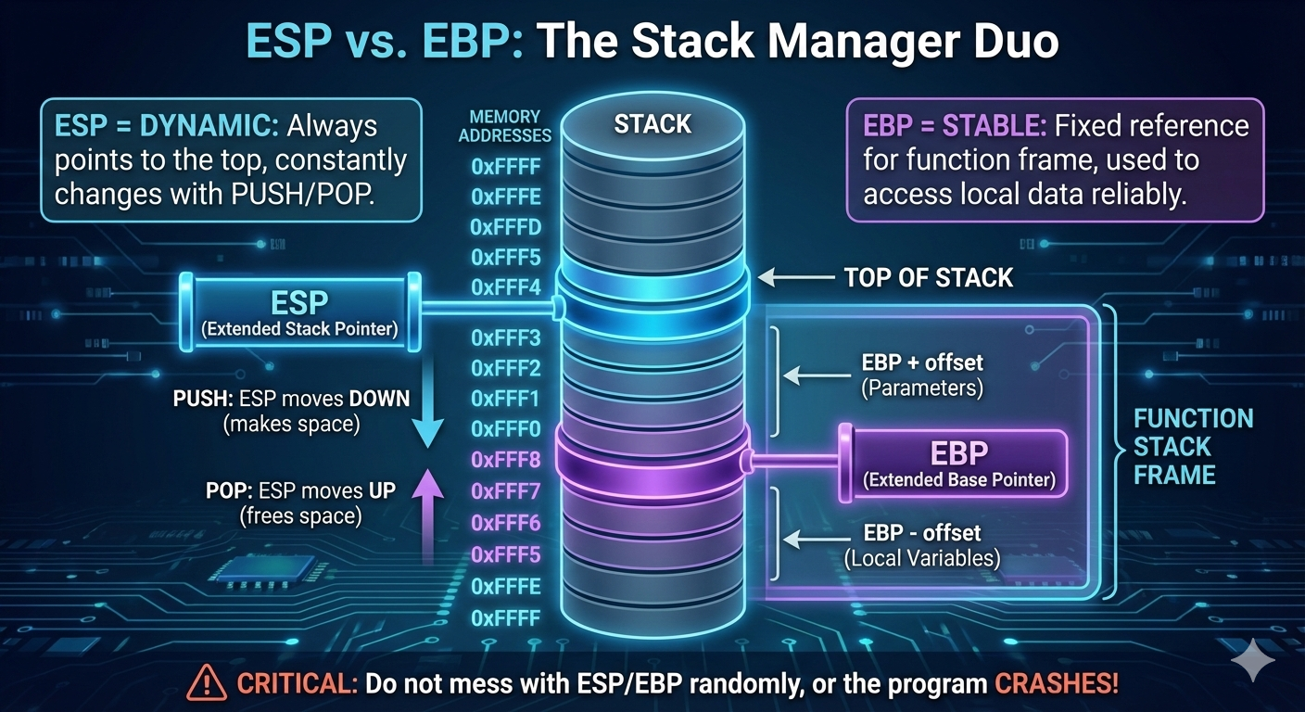

3.5 Register Breakdown Table (32-bit Architecture)

Visualizing how the registers overlap is crucial. Remember: Changing AL **changes** EAX. They are the same physical wires.

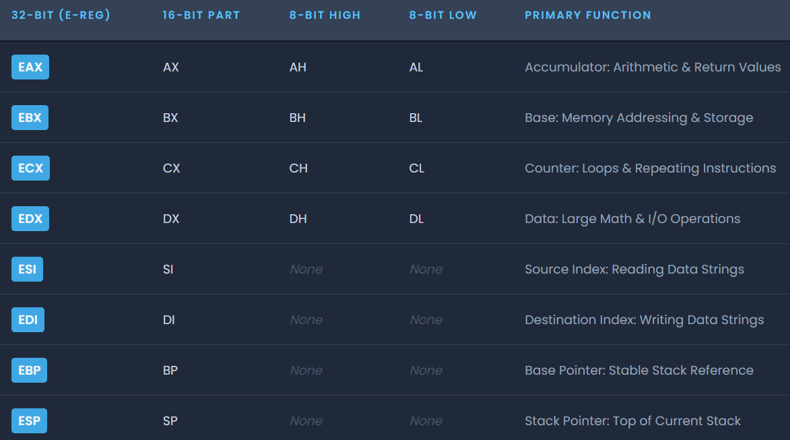

3.6 Reverse Engineering Insight: Register Slicing

Even in a 64-bit world, the small pieces of registers like AL and AH still matter.

A lot of real code works on bytes, not full 32-bit or 64-bit values.

Characters in strings, for example, are only 8 bits, so when a program checks a password one character at a time, it compares the value in AL against a single byte like 0x41 for the letter 'A', not the entire EAX register.

This also shows up in malware and obfuscated code.

Some malware avoids detection by building values one byte at a time using 8-bit registers.

Since many antivirus signatures look for known 32-bit patterns, assembling instructions byte-by-byte can help malicious code slip past simple pattern matching.

There’s also a practical performance reason.

Using smaller registers can reduce instruction size and sometimes be slightly more efficient.

Compilers and hand-written assembly will still use 8-bit operations when they make sense.

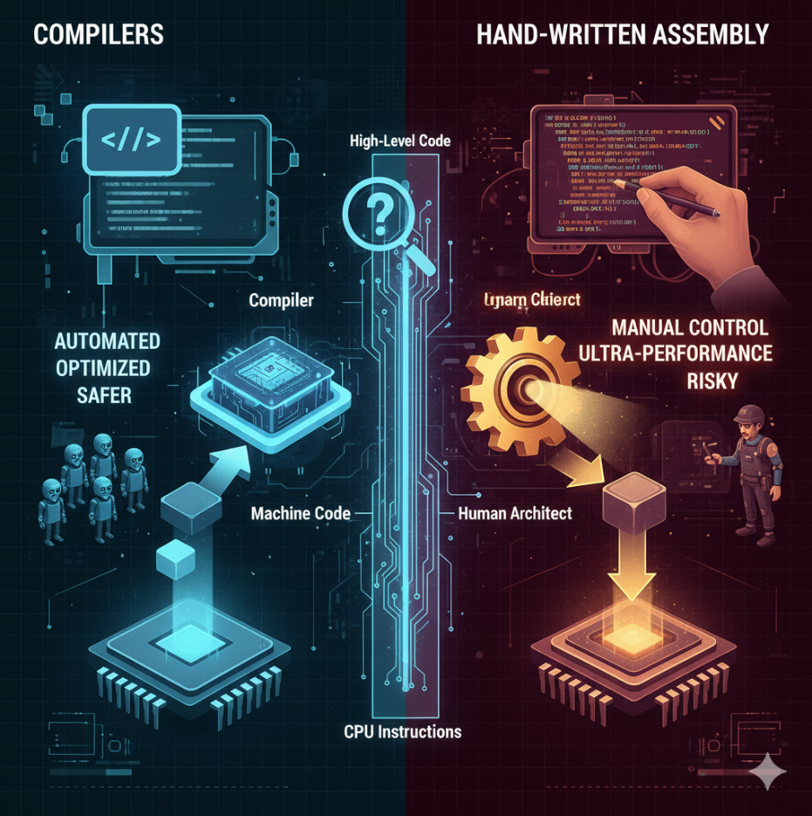

3.7 Chapter Review

If EAX contains the value 0x12345678, the lower 16 bits are stored in AX, so AX would be 0x5678.

The lowest 8 bits are stored in AL, which would be 0x78.

You can’t access a “high” or “low” 8-bit part of registers like ESI or EDI because only the core registers (A, B, C, and D) were designed with addressable 8-bit sub-registers.

Registers like ESI, EDI, EBP, and ESP must be accessed as 16-bit or 32-bit values.

When a function finishes running, its return value is placed in EAX.

If you want to know whether a function succeeded or failed, that’s the register you check.

SPECIAL PURPOSE REGISTERS (x86) **🧩⚙️**

1.1 What “Special Purpose” Really Means

Special-purpose registers are registers that exist to **control the CPU itself**, not just to hold random data. They:

* Control **execution flow**
* Control **memory access**
* Track **CPU state**
* Enable **debugging, protection, and task switching**

Unlike general-purpose registers:

* Some of them **cannot be freely used**
* Some are **invisible to normal programs**
* Some can crash the system if misused

Think of them as: *“The steering wheel, brakes, and dashboard of the CPU”*

You don’t casually play with them.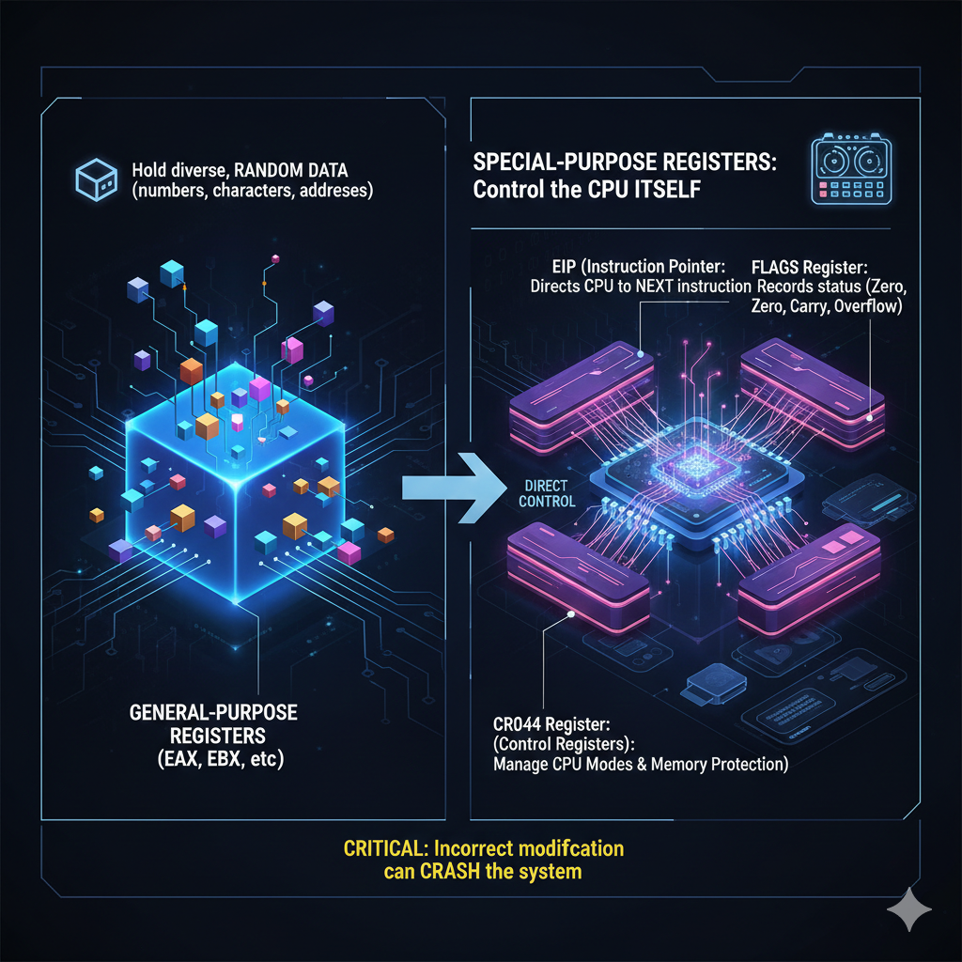

1.2 Instruction Pointer (IP / EIP) **🧭**

**What it is**

The **Instruction Pointer** holds the memory address of the **next instruction** the CPU will execute.

* 16-bit mode → IP
* 32-bit mode → **EIP**
* 64-bit mode → RIP

You almost never write to EIP directly.

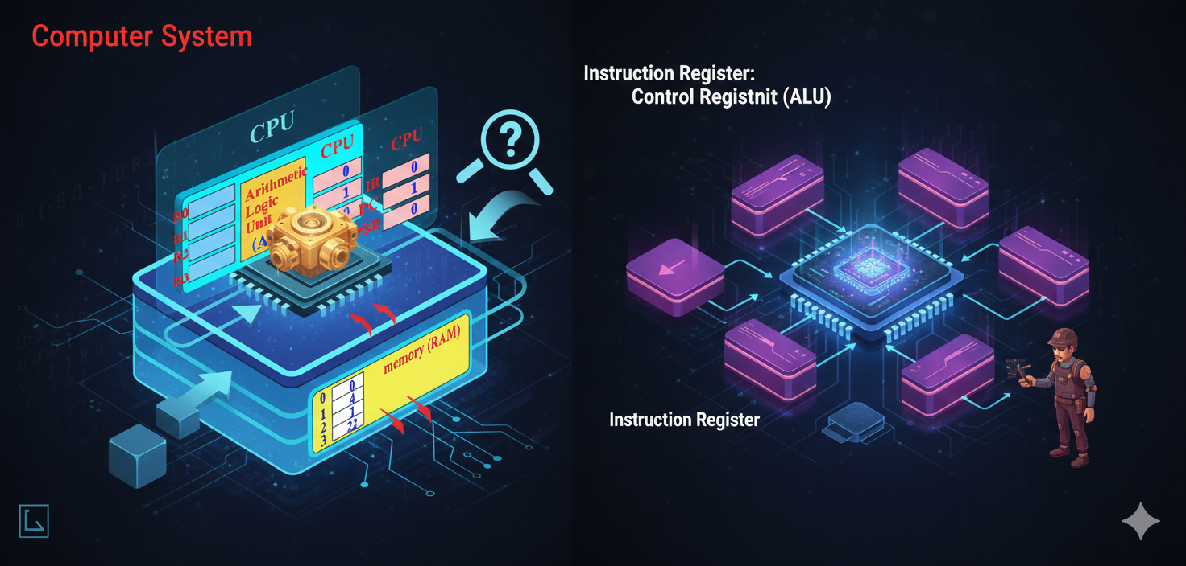

Instead, it changes through:

* JMP
* CALL
* RET
* Interrupts
* Exceptions

Example mental model:

EIP is the CPU’s “you are here” arrow.

If you control EIP:

* You control **execution**
* You control **program flow**
* You own the process

This is why exploits aim to:

**Overwrite EIP**

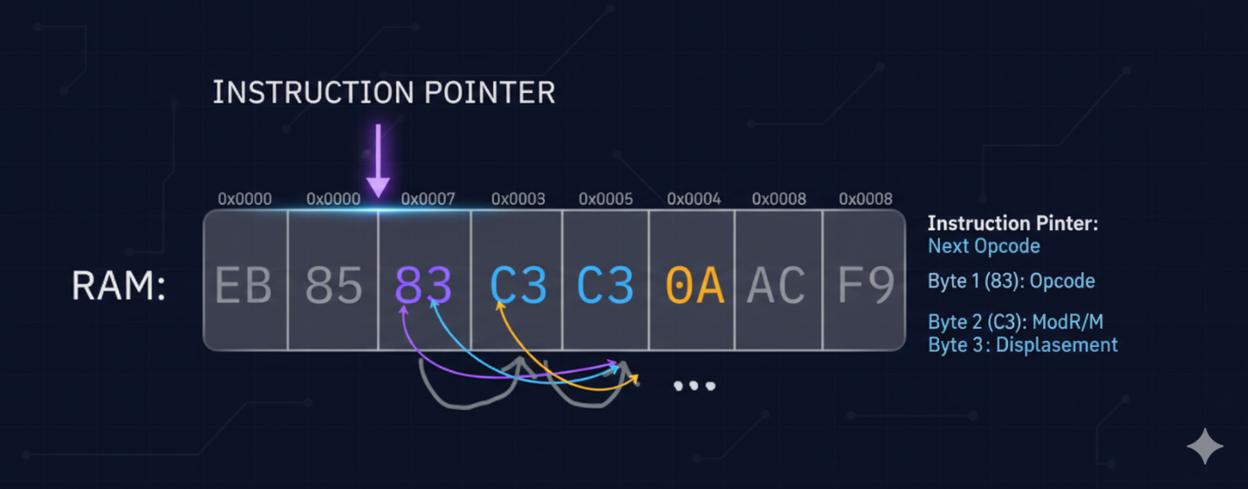

1.3 Flags Register (FLAGS / EFLAGS) **🚦**

**What it is**

The Flags Register stores **status bits** describing what just happened in the CPU.

After arithmetic or logic:

* Was the result zero?
* Was there a carry?
* Was there an overflow?
* Was the result negative?

Common flags:

* ZF → Zero Flag
* CF → Carry Flag
* OF → Overflow Flag
* SF → Sign Flag

Example:

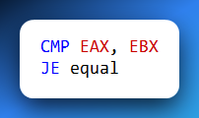

CMP does **not** jump.  
It only sets flags.

JE checks:

“Is ZF = 1?”

Flags are the **decision-makers** behind conditional jumps.

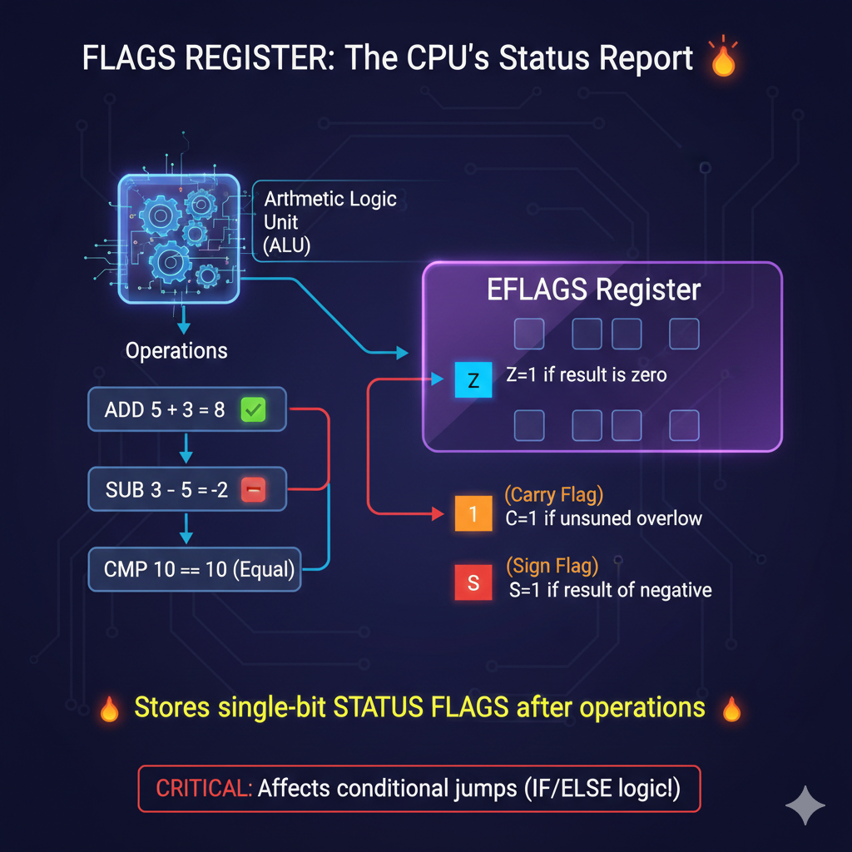

1.4 Stack Pointer (SP / ESP) **📦**

**What it is**

ESP always points to the **top of the stack**.

The stack is used for:

* Function calls
* Return addresses
* Local variables
* Saved registers

Key rules:

* PUSH → ESP decreases
* POP → ESP increases

ESP is automatically modified by the CPU.

Important:

ESP is both **general-purpose in theory** and **special-purpose in reality**

You *can* use it as a normal register.  
You *shouldn’t* unless you’re advanced.

Corrupt ESP → corrupted execution.

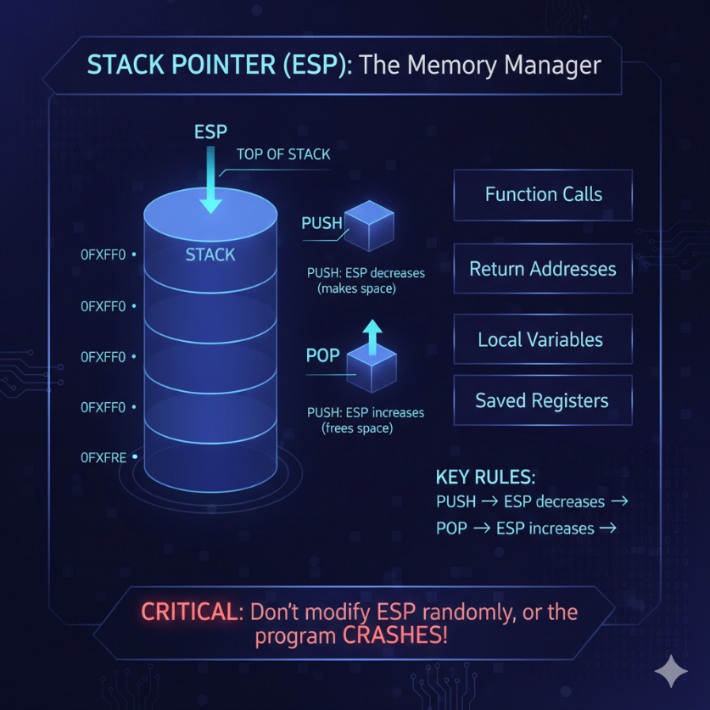

1.5 Base Pointer (BP / EBP) **🧱**

**What it is**

EBP points to the **base of the current stack frame**.

It provides:

* Stable access to function arguments
* Stable access to local variables

Unlike ESP:

* EBP usually stays fixed during a function

Example:

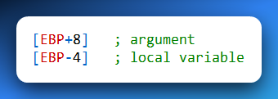

Why debuggers love EBP:

* Stack frames become readable
* Call chains become visible

Why optimizers remove it:

* One less register used
* Faster code

So yes:

EBP is special-purpose **by convention**, not by force.

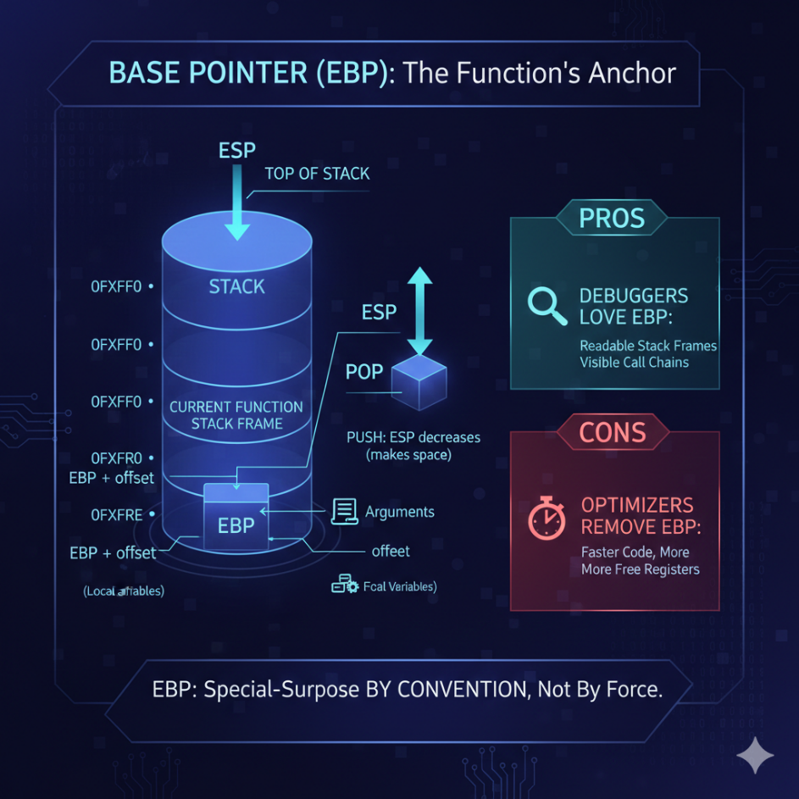

1.6 Index Registers (SI, DI, ESI, EDI) **🔁**

**What they are:** Index registers are optimized for **string and array operations**. They shine in:Memory copying, Memory comparison and Buffer processing.

Roles:

* ESI → Source Index
* EDI → Destination Index

Used by instructions like:

* MOVS
* CMPS
* LODS
* STOS
* SCAS

With REP + ECX: The CPU becomes a **hardware memory mover**. This is why malware loves them.

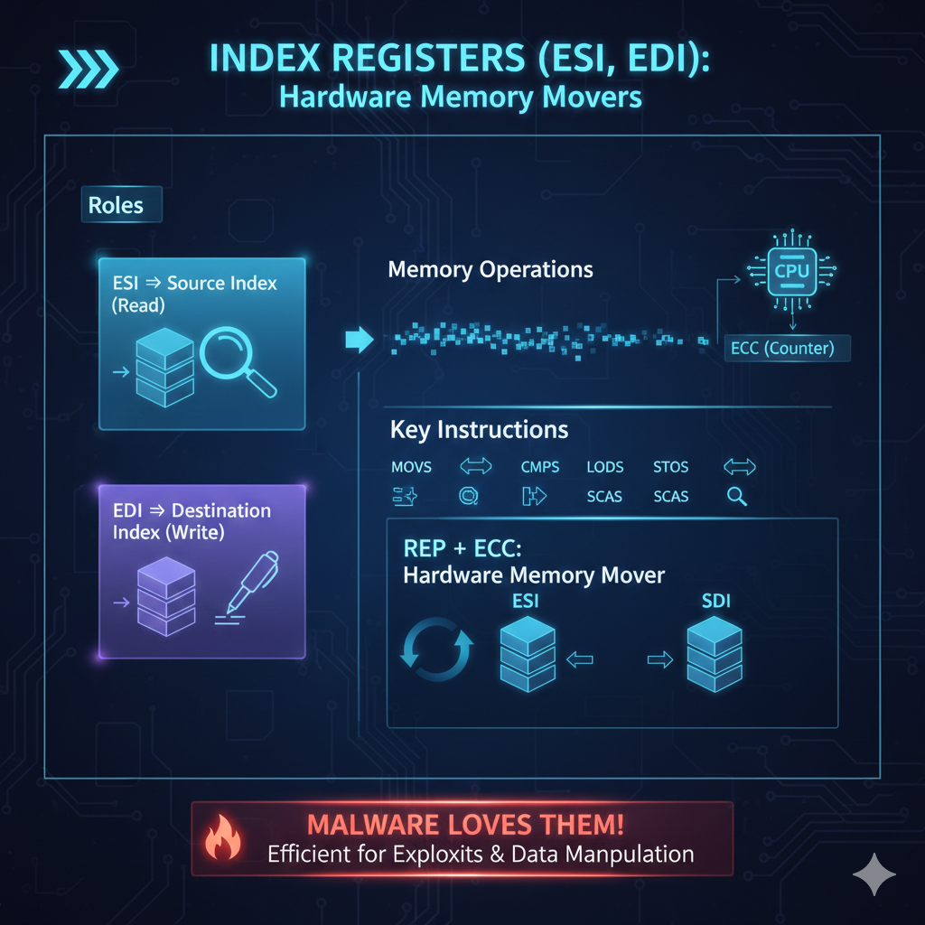

1.7 Segment Registers (CS, DS, SS, ES, FS, GS) **🧠🧱**

**What they are**

Segment registers define **which segment of memory** you are accessing.

Historically:

* Memory was divided into segments
* Each segment had a base address

Key ones:

* CS → Code Segment
* DS → Data Segment
* SS → Stack Segment

Modern systems:

* Segmentation is mostly hidden
* Paging dominates

But:

* FS / GS are still heavily used
* Thread-local storage
* OS internals
* Malware tricks

Segment registers are **not obsolete** — just less visible.

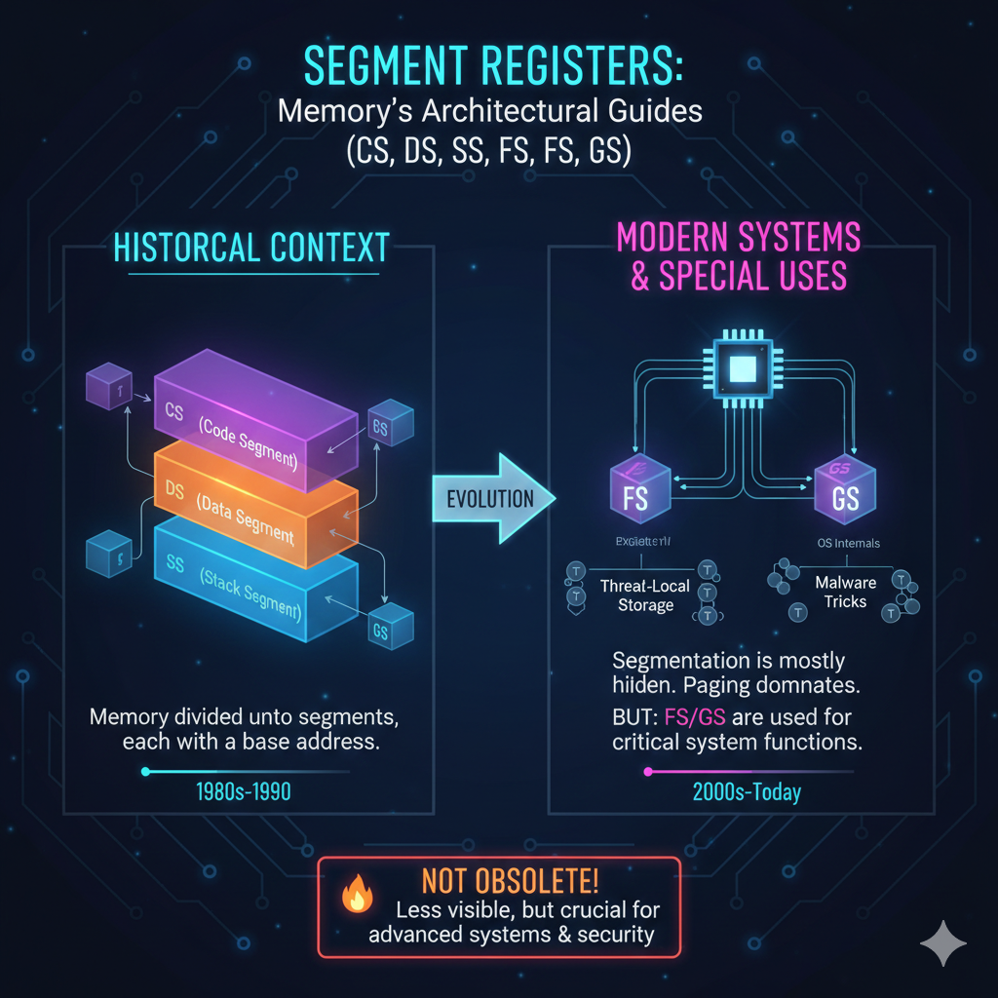

1.8 Control Registers (CR0, CR2, CR3, CR4, CR8) **🔐**

**What they are**

Control registers define **how the CPU operates**.

They control:

* Protected Mode
* Paging
* Virtual memory
* Write protection
* Supervisor/User mode behavior

Examples:

* CR0 → enables protected mode
* CR3 → holds page directory base
* CR2 → stores faulting address (page fault)

Normal programs **cannot touch these**. Only kernel-mode code can.

These registers separate the user code from the operating system

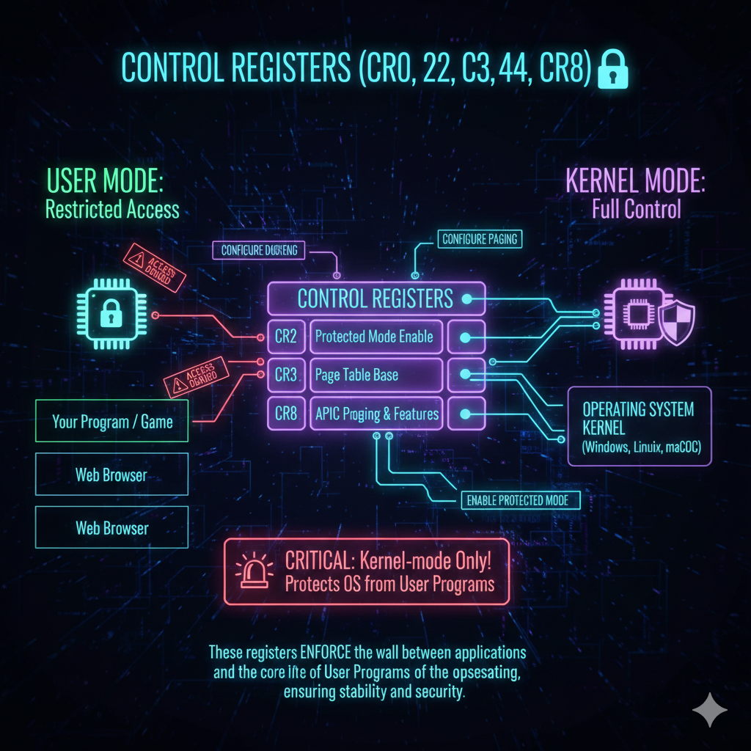

1.9 Debug Registers (DR0–DR7) **🐞**

**What they are**

Hardware debugging registers.

They allow:

* Breakpoints on memory access
* Breakpoints on execution
* Monitoring without code modification

Used by:

* Debuggers
* Anti-debugging checks
* Malware evasion

Malware often:

* Detects DR registers
* Clears them
* Behaves differently if debugging is detected

1.10 Model-Specific Registers (MSRs) **🧪**

**What they are**

CPU-vendor-specific registers.

Used for:

* Performance counters
* Power management
* Feature toggles
* Security extensions

Accessed using: **RDMSR** and **WRMSR**

Highly privileged.  
Highly dangerous.  
Highly powerful.

1.11 Task Register (TR) **🔄**

**What it is**

The Task Register points to the **Task State Segment (TSS)**.

Used in:

* Hardware task switching (mostly legacy)
* Interrupt stack switching
* Privilege transitions

Modern OSes:

* Rarely use full hardware task switching
* Still rely on TSS for interrupts

1.12 Local Descriptor Table Register (LDTR) **📋**

**What it is**

LDTR points to the **Local Descriptor Table**.

LDT:

* Defines per-task memory segments
* Used in protected mode

Mostly historical, but:

* Still exists
* Still relevant in deep OS internals

1.13 The ESP / EBP “Double Identity” Explained

Yes — ESP and EBP sit in **both worlds**.

They are:

* General-purpose by hardware
* Special-purpose by convention

Why?  
Because breaking convention:

* Breaks tools
* Breaks debuggers
* Breaks expectations

Registers like EAX or EBX:

* Have **no execution role**
* Pure data containers

ESP and EBP:

Are data **and structure**

That’s the difference.

1.14 “E”, “R”, and the Evolution of Register Names **🧬**

* AX → 16-bit (real mode)
* **EAX → 32-bit (extended)**
* RAX → 64-bit (long mode)

So yes:

**“E” stands for Extended**

It marks the jump from:

* 16-bit world
* To 32-bit protected mode

The prefix tells you:

* CPU generation
* Execution mode
* Operand size

1.15 Why This Chapter Matters

If you don’t understand special-purpose registers:

* You don’t understand crashes
* You don’t understand exploits
* You don’t understand OS boundaries

These registers:

Decide *who* runs, *where*, and *how*

General-purpose registers do work.  
Special-purpose registers **decide the rules**.